DestiNation Guide

A PROJECT REPORT
Submitted by

KATHIRIYA HARSHIL NARSHBHAI | 21BECE30103
TALAVIYA VIHAR JAYESHKUMAR | 21BECE30316
PATEL KATHAN SANJAYKUMAR | 21BECE30203
KANANI VISHVA RUGHNATHBHAI | 21BECE30100

In fulfillment for the award of the degree
of
BACHELOR OF ENGINEERING
in
Computer Engineering

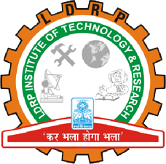
LDRP Institute of Technology and Research, Gandhinagar
Kadi Sarva Vishwavidyalaya
JANUARY, 2024

LDRP Institute of Technology and Research
Gandhinagar

CE-IT Department
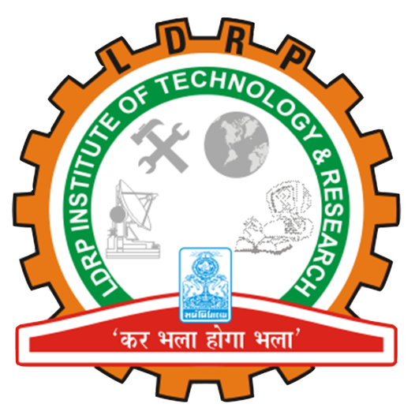

CERTIFICATE
This is to certify that the Project Work entitled “DestiNation Guide” has been carried out by Talaviya Vihar Jayeshkumar[21BECE30316] under my guidance in fulfilment of the degree of Bachelor of Engineering in Computer Engineering Semester-6 of Kadi Sarva Vishwavidyalaya University during the academic year 2022-2023.

Name of Guide Name of HOD
Hitesh Patel Sandip Modha
LDRP ITR LDRP ITR
Presentation-I for Project-I
1. Name & Signature of Internal Guide
2. Comments from Panel Members
3. Name & Signature of Panel Members

